 | Kindergarten - Course A  Program using commands like loops and events. Teach students to collaborate with others, investigate different problem-solving techniques, persist in the face of challenging tasks, and learn about internet safety.
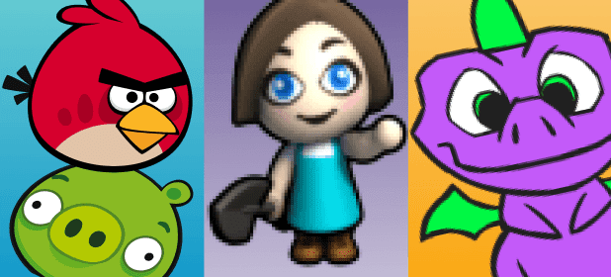 | 1st Grade - Course B  Through unplugged activities and a variety of puzzles, students will learn the basics of programming, collaboration techniques, investigation and critical thinking skills, persistence in the face of difficulty, and internet safety.
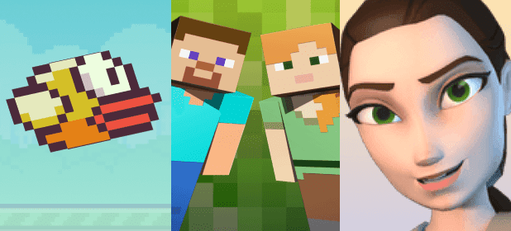 | 2nd Grade - Course C  Create programs with sequencing, loops, and events. Investigate problem-solving techniques and develop strategies for building positive communities both online and offline. Create interactive games that students can share.
 | 3rd Grade - Course D  Review of the concepts found in earlier courses, including loops and events. Afterward, students will develop their understanding of algorithms, nested loops, while loops, conditionals, and more.
 | 4th Grade - Course E  Make fun, interactive projects that reinforce learning about online safety. Engage in more complex coding such as nested loops, functions, and conditionals.
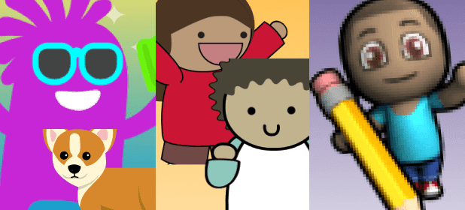 | 5th Grade - Course F  Look at how users make choices in the apps they use. Make a variety of Sprite Lab apps that also offer choices for the user. Learn more advanced concepts, including variables and “for” loops.

